Naveen Bonala Aws ALB, NLB & CLB

1. Configure Classic Load balancer.





1. Configure Application Load balancer.





1. Configure Network Load balancer.





1. Attach SSL for application load balancer.

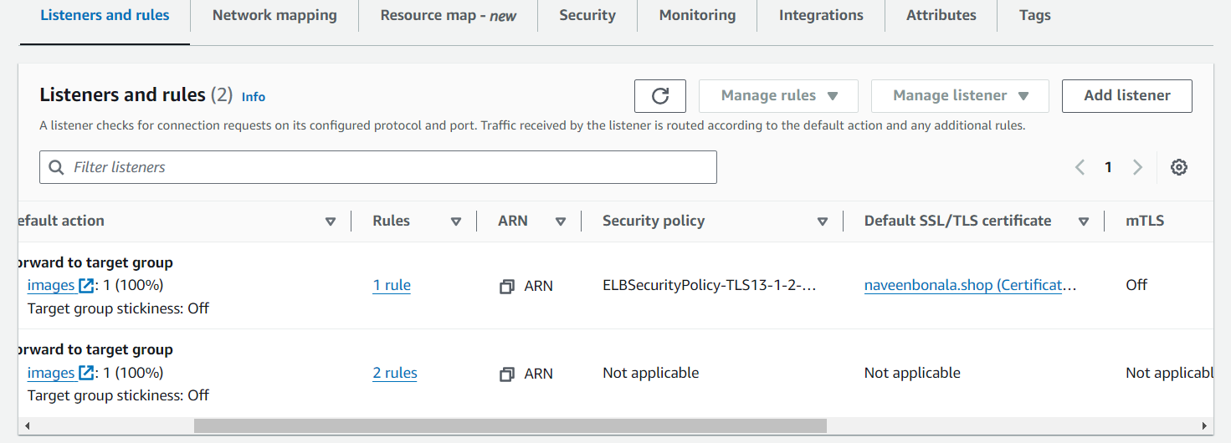

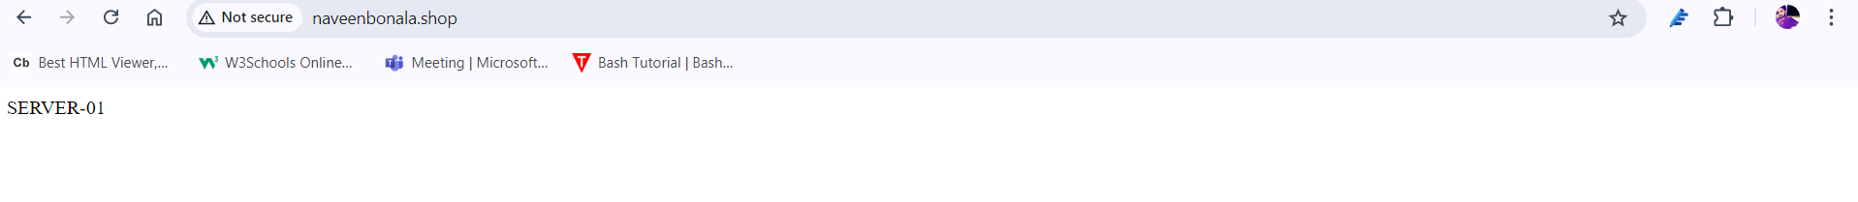

1. Map Applciation load balancer to R53.

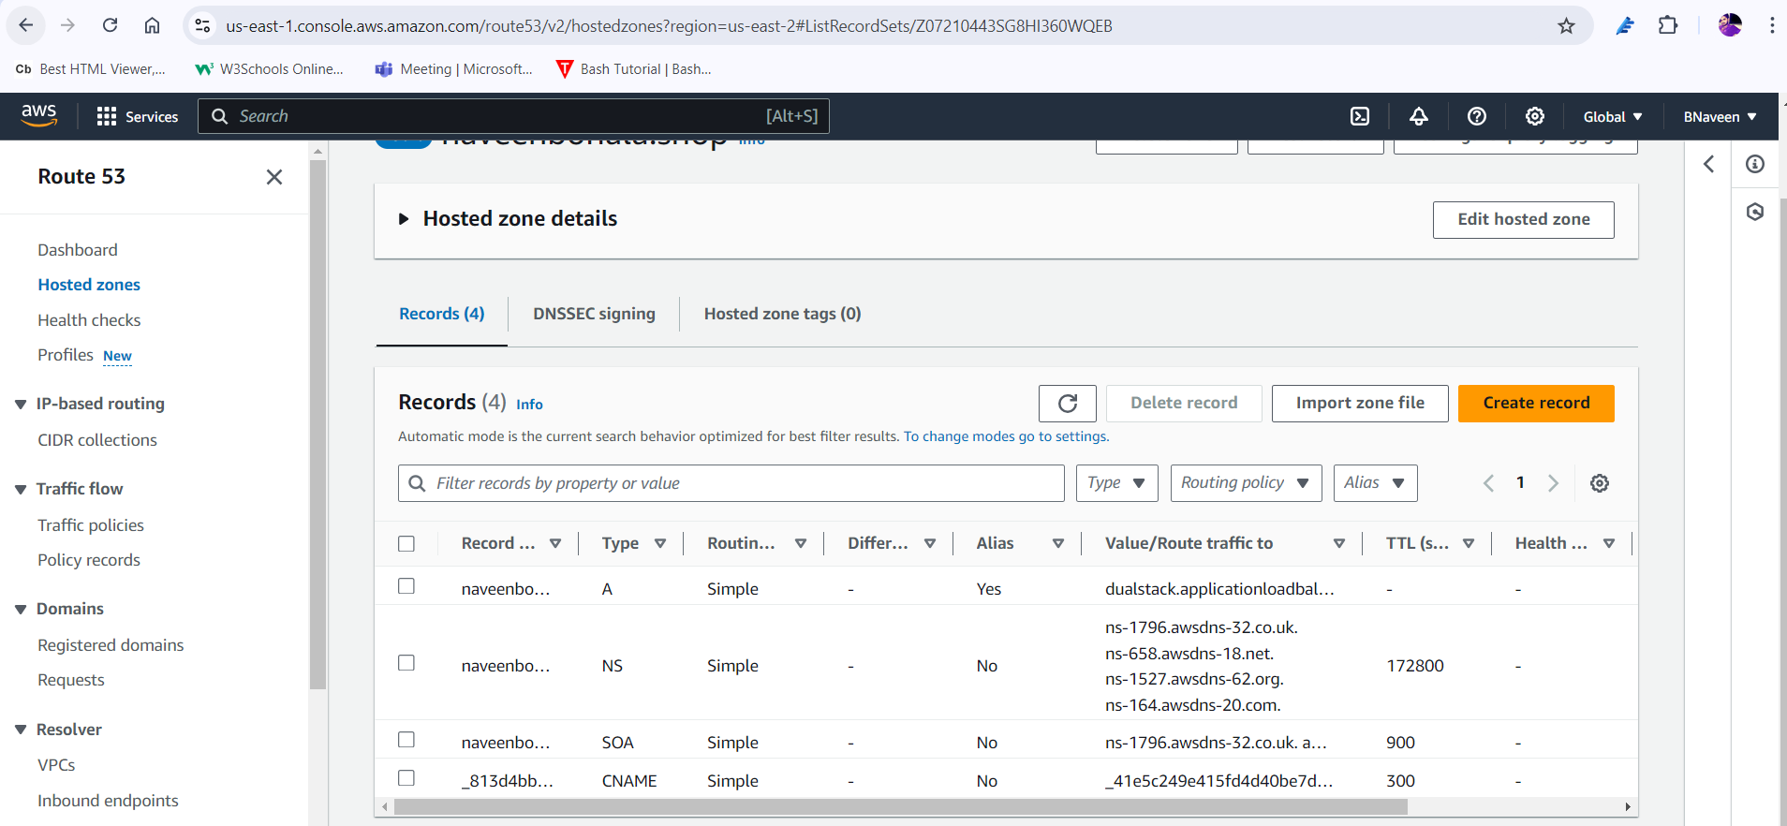

6) Push the application load balancer logs to s3.

